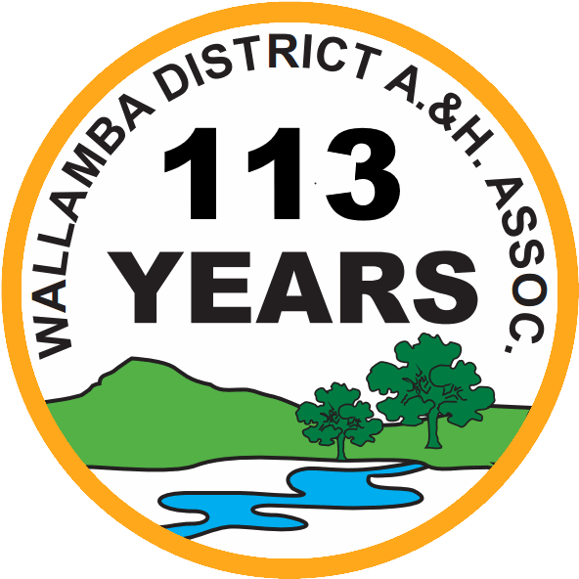
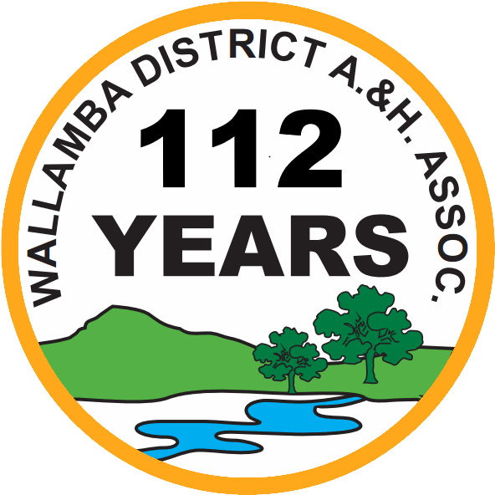
Wallamba District Agricultural & Horticultural Assoc. Inc.
Showground Lane, Nabiac NSW 2312
ABN 36 676 182 015

Secretary: Lyn Reid
Email: secretary_wdah@outlook.com
Ph: 6559 1811
Wallamba Tug-o-War Championship
at the show on Saturday, 7th March, 2026
ENTRY TERMS:
- Number of teams capped at 16.
- By submitting an entry form, the team confirms it has read and agrees to abide by the Rules.
- Entry fee is $10.00 per team.
- Prizes: Male teams $300 1st, $100 2nd, Female teams $300 1st, $100 2nd
Children $200 (to be shared)
- Teams to gather at base of Announcer’s box by 3pm on show day.
- All entries to be submitted prior to the 7th March, 2026
- Email together, completed entry form and evidence of Eftpos payment to: secretary_wdah@outlook.com
- Make payment by bank transfer to:
Wallamba District A & H Assn. Inc.
BSB: 012 626 Account: 236407894
PLEASE identify payment by team name

ENTRY FORM

Name of Tug-o-war team: …………………………………………………………………………………

Team Contact person: ……………………………………………………………………………………….

Ph.#: ……………………………… Email: ……………………………………………………………………..

Please sign to agree to the Terms and Rules

Signature: ……………………………………………………… Position: …………………………………

Please print name: ……………………………………………………………………………………………

